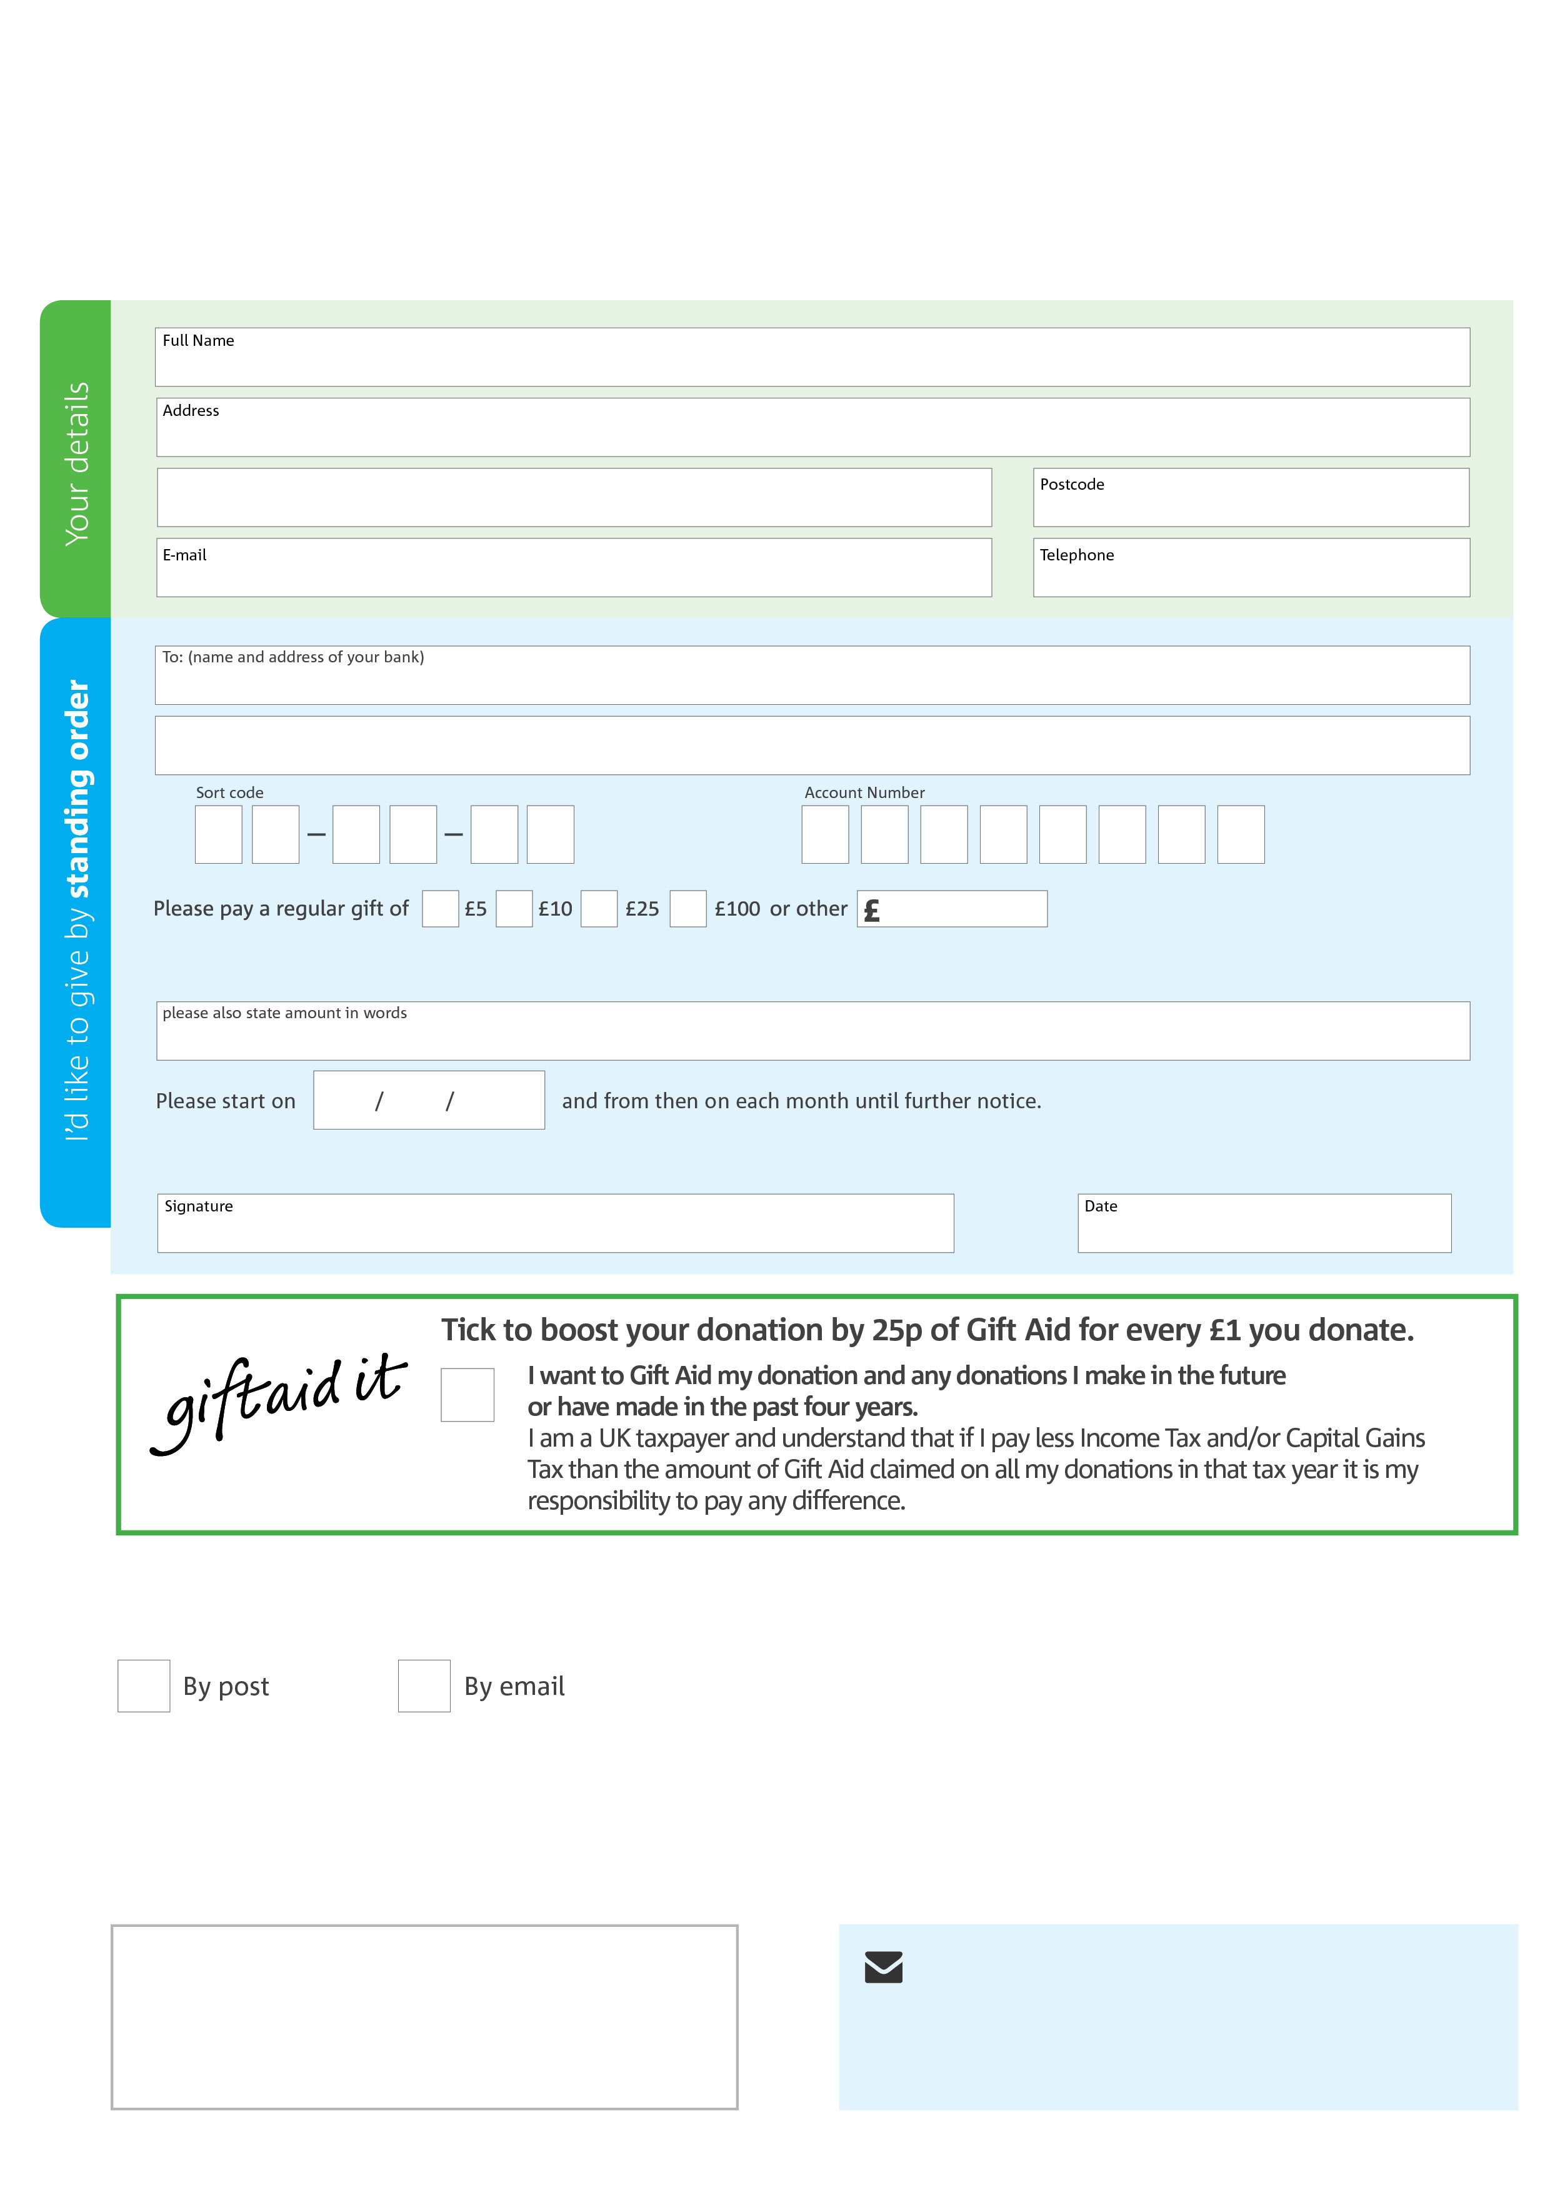­

**Data protection**

Taunton Foodbank is committed to protecting your privacy and will process your personal data in accordance with the Data Protection Act 1998. Taunton Foodbank collects information to keep in touch with you and supply you with information relating to our work. Taunton Foodbank will never sell or pass your details to anyone who isn’t directly working on our behalf.

**We would love to keep in touch with you so we can update you on our work. You can change your preferences any time by contacting us on 07761 624216 or emailing us at info@taunton.foodbank.org.uk**

**Please tick here if you would be happy to receive communications from us:**

**Taunton Foodbank’s bank details:**

Address:

Sort code: 60-80-06

Account number: 59881410

**Please send your completed form to**

Unit 4, Belvedere Trading Estate

Albemarle Road, Taunton

Somerset, TA1 1BH

This cancels any previous standing order instructions to Taunton Foodbank

To Taunton Foodbank each month,

taunton.foodbank.org.uk

Reg. Charity No: 1163094 | Reg. in England & Wales